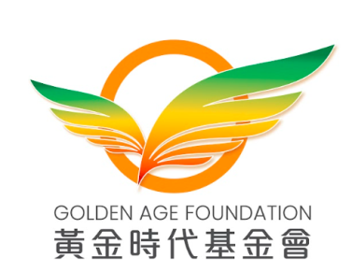
Application Form for Corporate Membership

Institution Information
Name | (Chinese)  (English)
Address
Tel. No.
Email
Industry
Website
Responsible Person
Name
Title
Tel. No. | (Direct Line) (Mobile)
Email
Contact Person (1)
Name
Title
Tel. No. | (Direct Line) (Mobile)
Email
Contact Person (2)
Name
Title
Tel. No. | (Direct Line) (Mobile)
Email
Declaration
Personal Information Collection Statement
The corporate understands and agrees that the Golden Age Foundation will collect, use, and protect the personal data of its individual employees in accordance with relevant laws and regulations. The personal data collected will only be used to process applications for membership, manage memberships after acceptance, and improve the activities, communications, and services of the Golden Age Foundation.
Receive promotions and latest news
The corporate would like to receive the latest information from the Golden Age Foundation via email, text message or other means, including event notifications, fundraising information, related updates and promotional information.

Notes:
- Any institutions (except those invited) can become a corporate member after submitting an application form and being approved by the Golden Age Foundation (hereinafter referred to as the Foundation).
- The membership fee is HK$1,000 per year. Please complete the application form and mail it together with the membership fee cheque (payable to: Golden Age Foundation) or payment transfer record (Account Number (for HKD): 012-721-1-015290-1, Bank Name: Bank of China (Hong Kong) Limited) to 9/F, Fortis Building, 77-79 Gloucester Road, Wan Chai.
- The Foundation will use the contact information you provide to keep in touch with you and to release the latest news and event information of the Foundation. The information you provide will be kept strictly confidential and will not be used for purposes other than the above.
- For enquiries, please contact the Secretariat of the Foundation at (852) 8102 1068 or email to info@goldenage.foundation.
- In case of any dispute, the Golden Age Foundation reserves the right of final decision.

